**Project Details**

|  |  |
| --- | --- |
| Project number | *13* |
| Project title | *Mega store corporation* |
| Corresponding TA\LA | *Dina Abbas* |
| Deliverable | *4* |

**Team Details**

|  |  |  |
| --- | --- | --- |
| **Student ID** | **Student name** | **Lab Group** |
| 20200186 | Reem Ayman Abdel-fattah | S7 |
| 20200228 | Salma Sherif Mostafa El-Sayed | S7 |
| 20201056 | Hasnaa Gamil Abdel-nabai | S7 |
| 20201064 | Rahma El-sayed Abo El-gheet | S7 |
| 20200140 | Habiba Ayman El-tahre | S1 |
| 20200173 | Dina Othman Emam | S1 |
| 20200734 | Sara Mahmoud Mohamed | S8 |

**Phase 4: Use case Realization**

**Deliver a complete electronic report to deliver the following requirements using CASE/modeling tool(s):**

1. Select **TWO** simple use cases using the provided Use case diagram (that have been developed during the analysis phase of your project)
2. Generate and draw a **partial class diagram** using **CRC cards** (**show steps**).

1. Generate and draw a **partial class diagram** using **communication diagram** (**show steps**).

add product

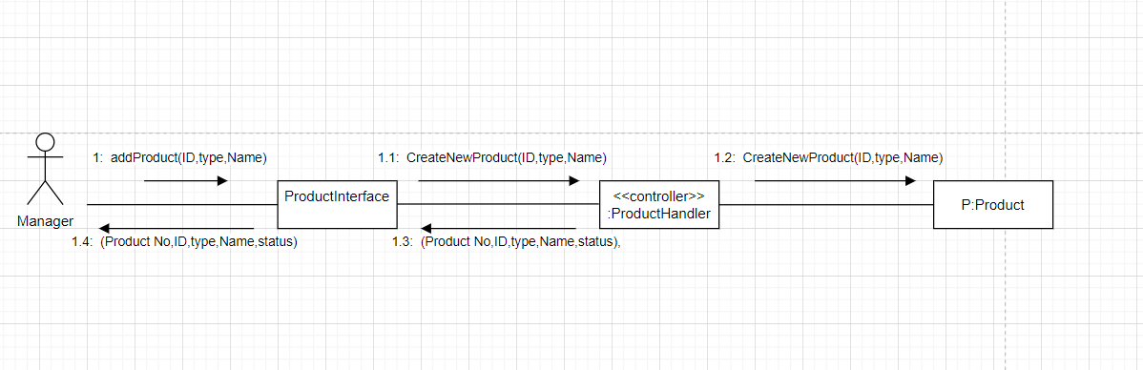

1. *CreateNewProduct message extended to all objects*

2.e*nterStore message extended to all objects*

Final communication diagram for *add product* use case

Partial class diagram for *add product* use case.

1. Select two complex use cases:

* Generate and draw a **partial class diagram** using **multi-layer sequence diagram** (**show steps**).

Pay for product

1-choose order to pay for

2-choose payment method

3- if choosing credit card method

4- if choosing point method and changing point

Partial class diagram

**Return a product**

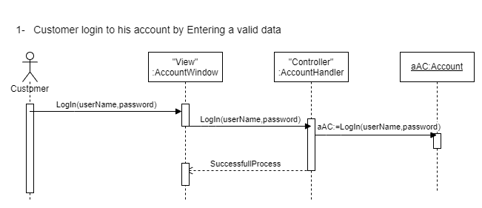

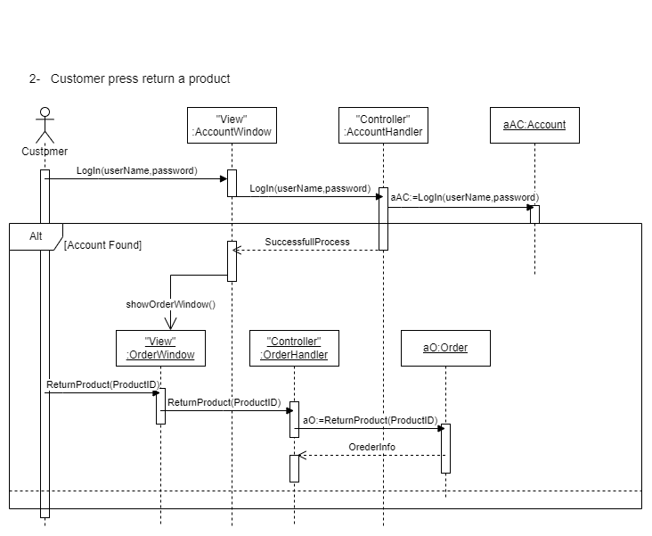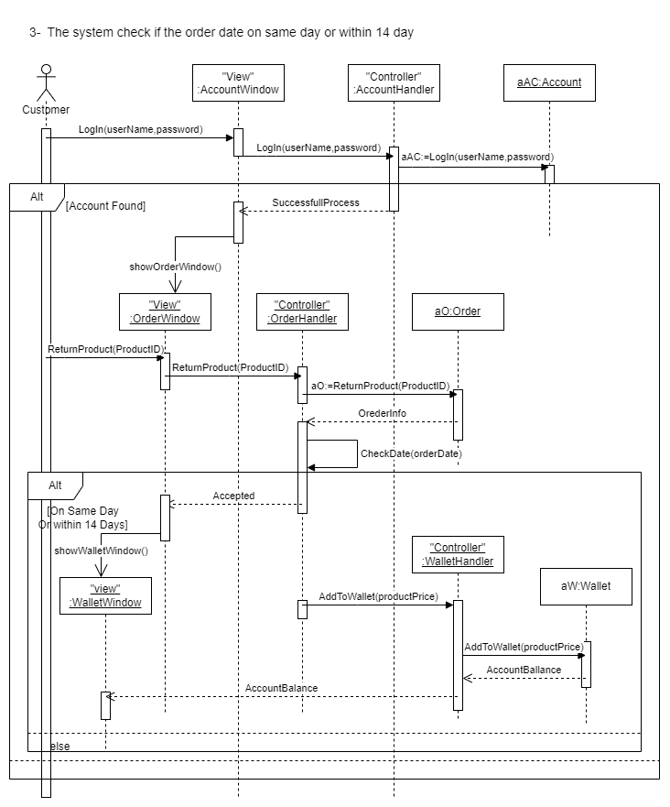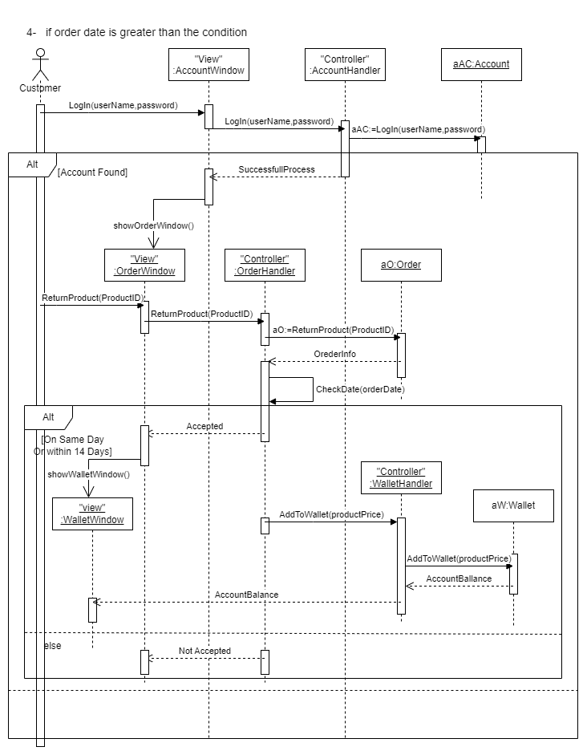

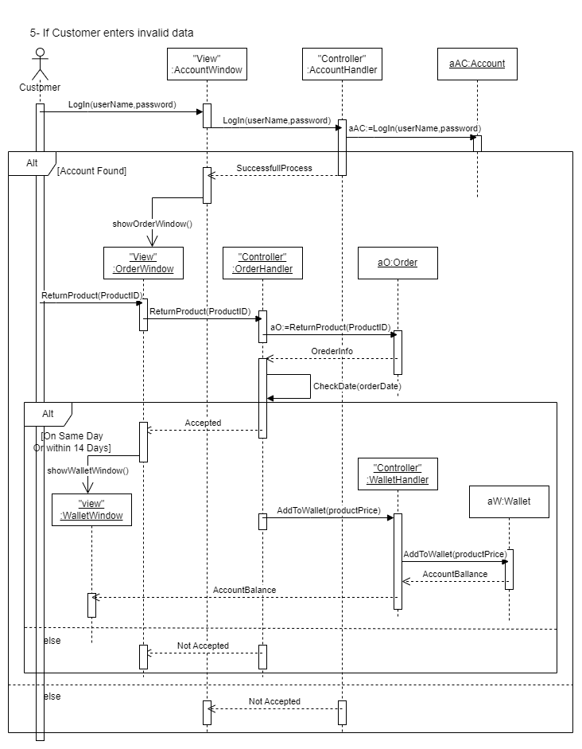

**Partial class diagram**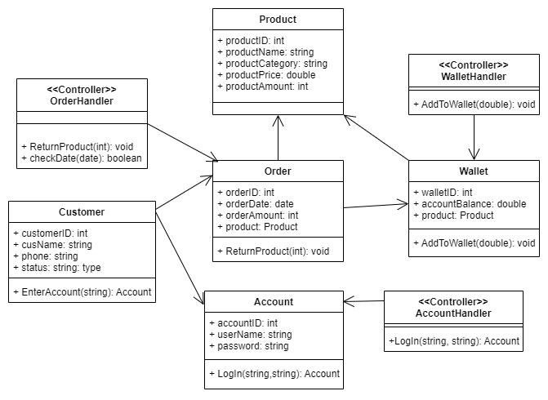

1. Generate and draw **final-cut class diagram** output from 1.a, 1.b, and 2 [**Fully-defined attributes and methods, navigation, multiplicity**].

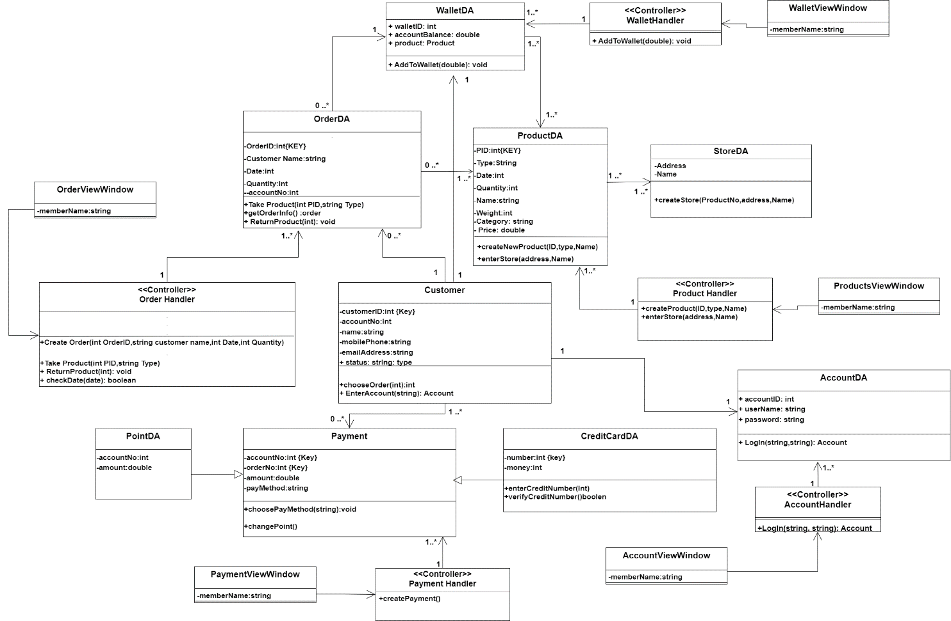

1. Generate and draw **package diagram** from the resulted detailed class diagram in 3.

